Question 3

Configure static IP addresses, modify MAC addresses, and verify network connectivity using ping and ifconfig commands.

Approach:

First we will check the ip of our device with ifconfig or ip a command.

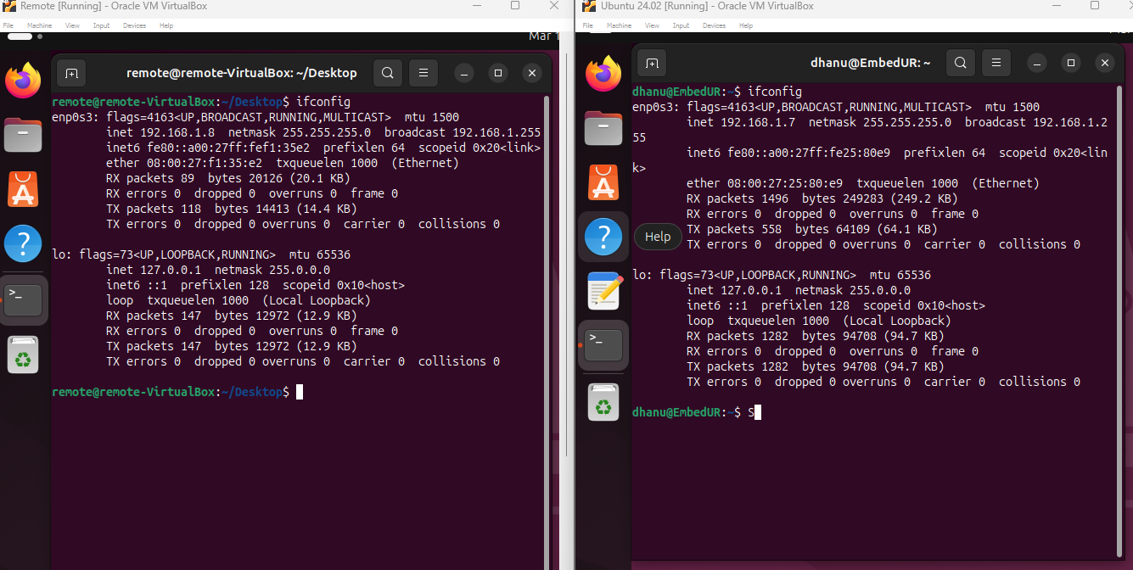

we will change the ip of our device. To change the ip of the device use the below command.

sudo ifconfig [your network] [ip.addr] netmask [addr] up

Ex: sudo ifconfig enp0s3 192.168.1.100 netmask 255.255.255.0 up

The above command help to change the ip address.

Note: Before changing the ip address keep in mind to check the ip range that your router allow from the web interface.

Below is my permited range. (it is always best practice to use the last values here 192.168.1.200)

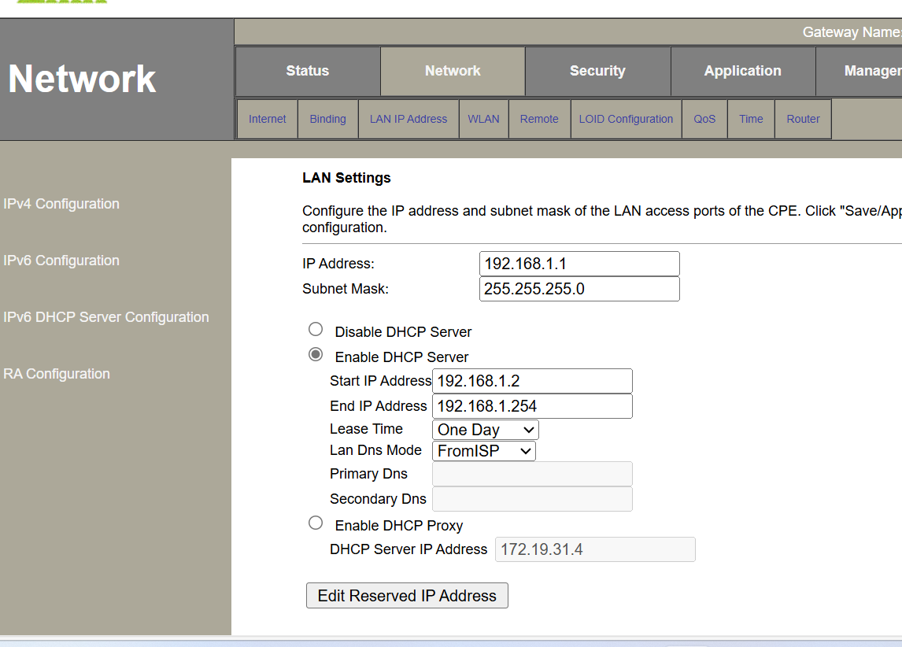

To change the mac address we can use macchanger in linux or to go with ifconfig,

sudo ifconfig [network name] hw ether [mac_addr]

We also have restrictions in assigning mac address. Once you changed the mc address, check the mac and ip address with ifconfig command.

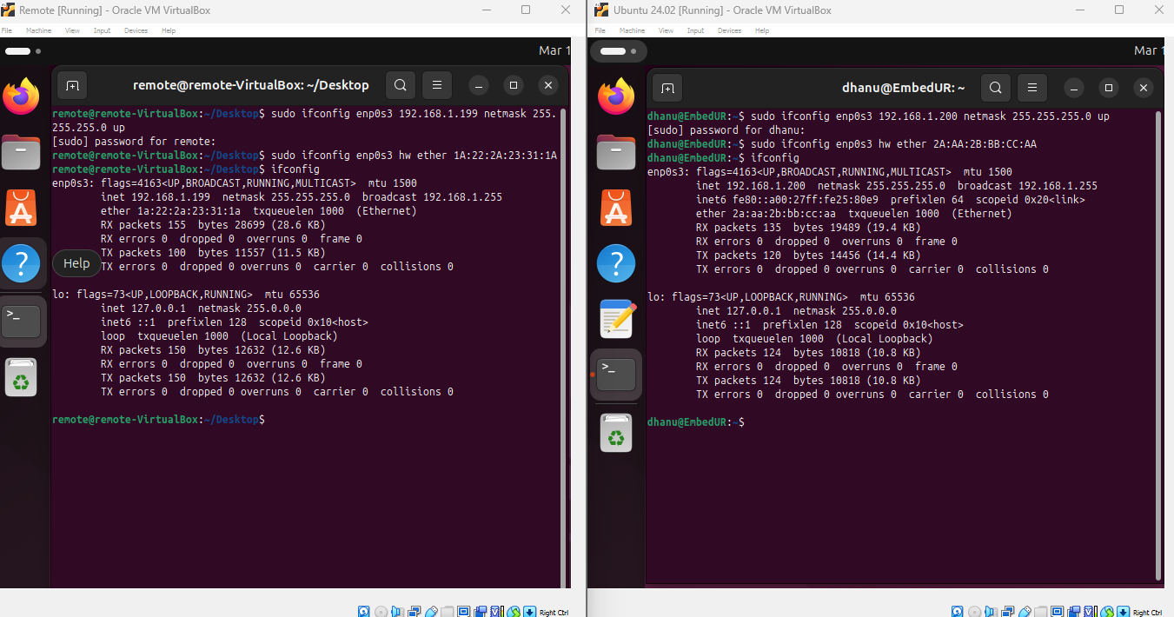

Sometimes we ay not get response once after the change.

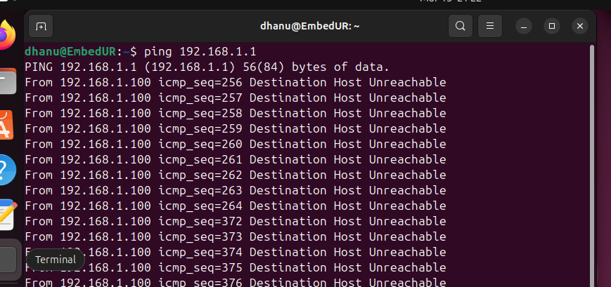

To overcome the problem we have to check the ip route whether there is a route available to192.168.1.1 (router).

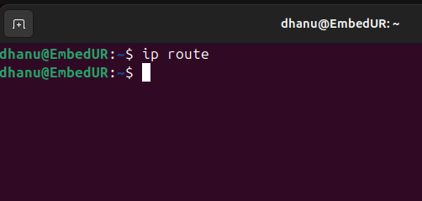

If not create one

sudo ip route add [ip_addr] via 192.168.1.1

if you get error like next hop has invalid gateway then use this command

sudo systemctl restart NetworkManager

then try the ip route add command

Once you done adding you can now ping to different ip with updated new ip

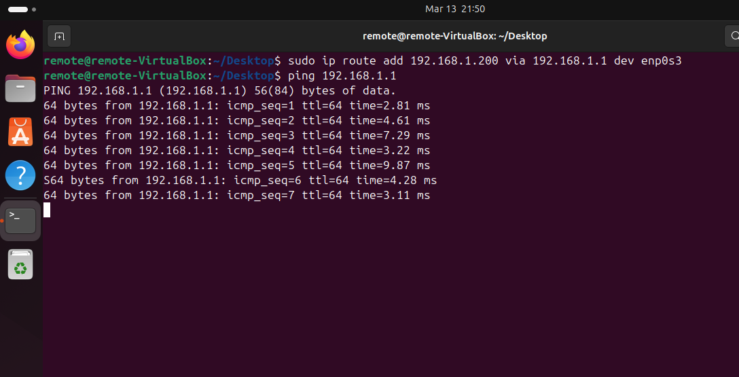

Issue in changing mac address

* Do not use a duplicate MAC it may cause network conflicts.
* Some networks may block changed MACs (like ISPs or corporate networks).